

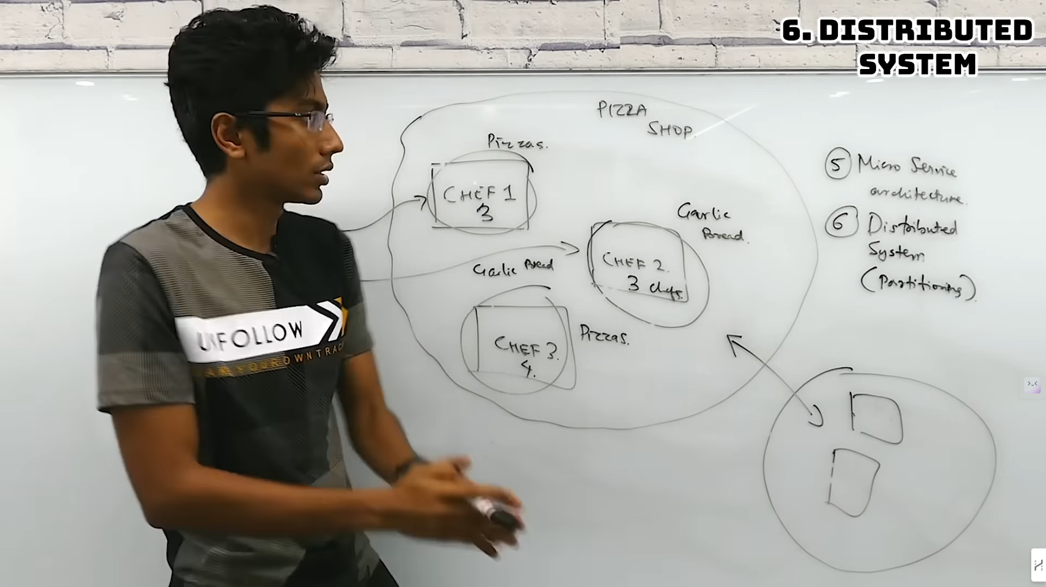

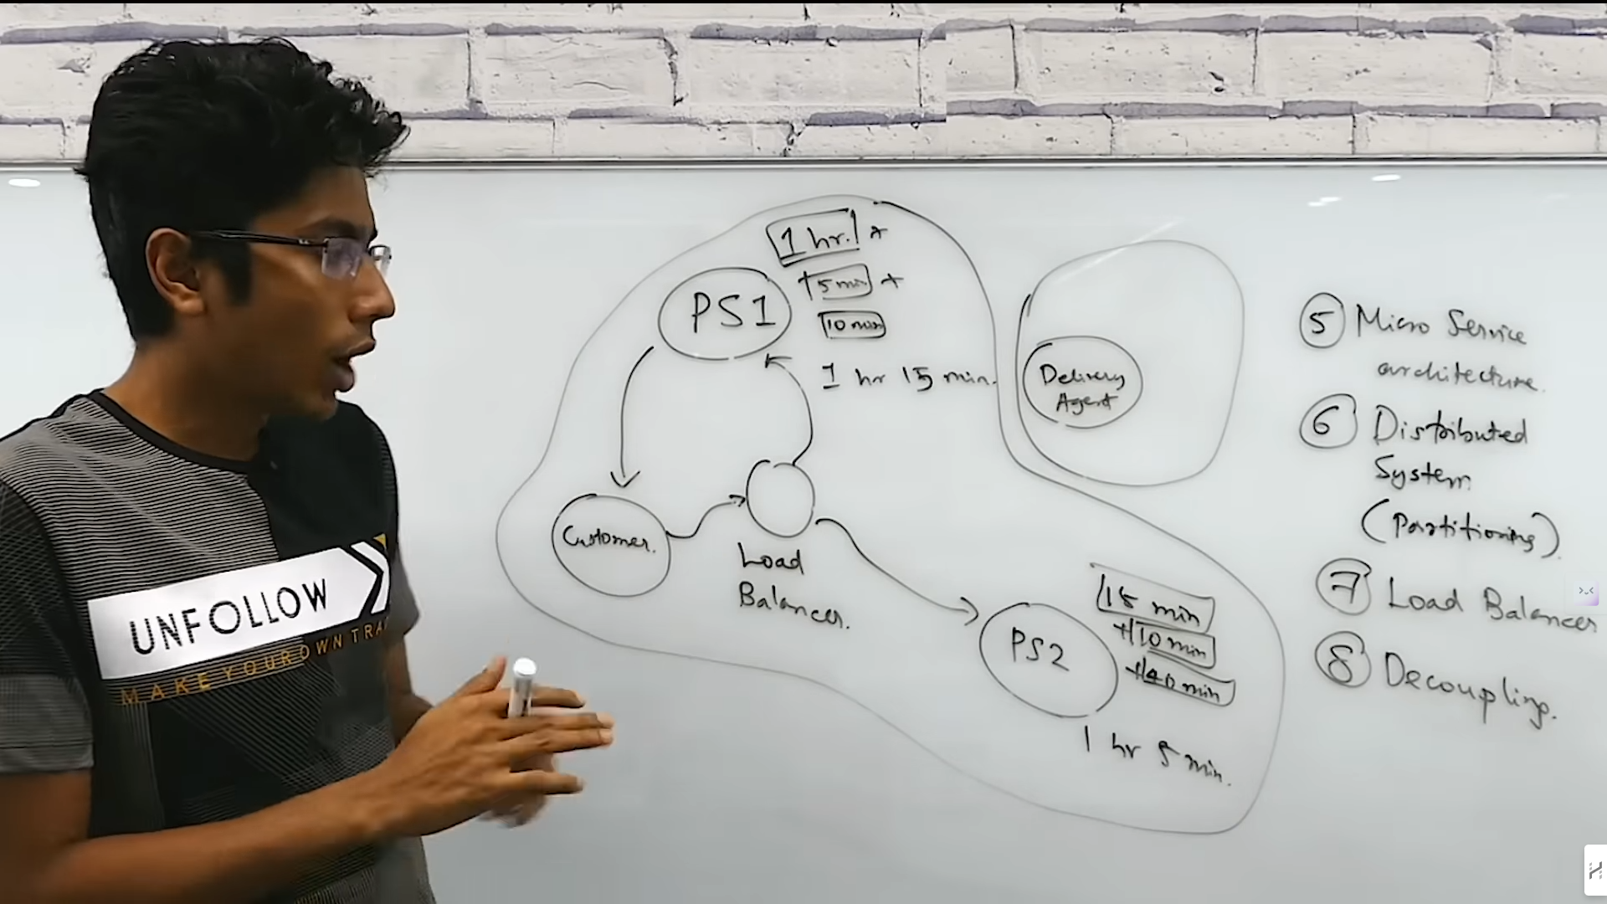



There are 2 Types of System Design : High Level Design and Low Level Design

High Level Design is all about the Deployment, scalability, extensible, fault Tolerance.

Low Level Design is how you write the Code actually.

11/11/24

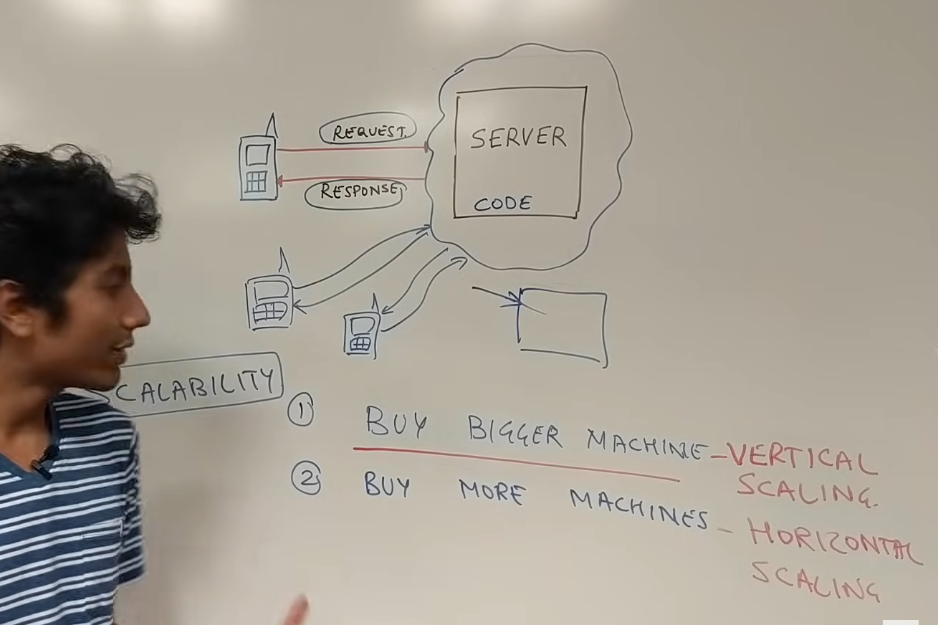

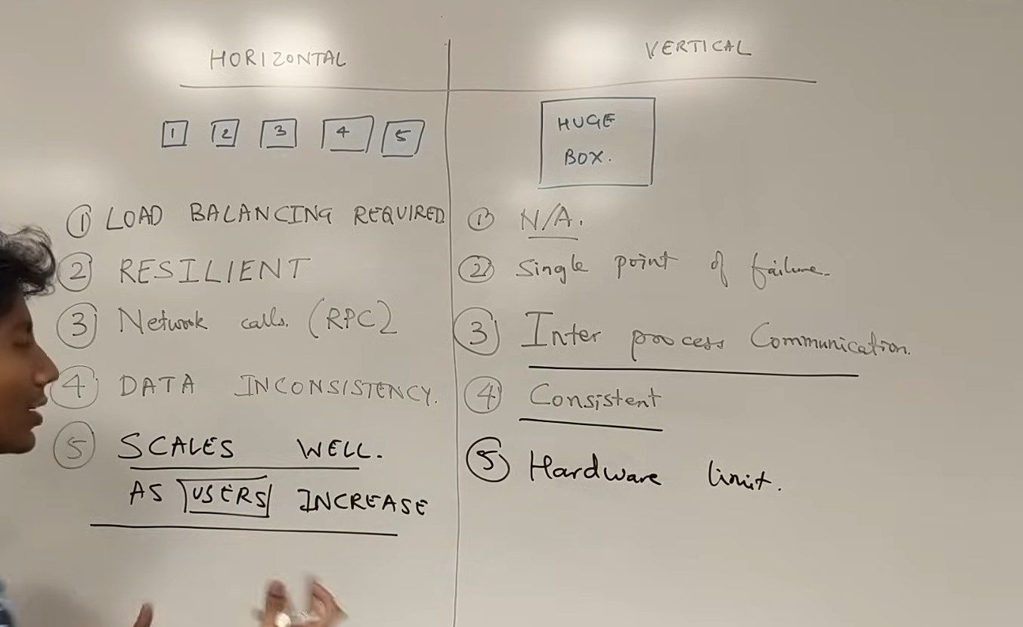



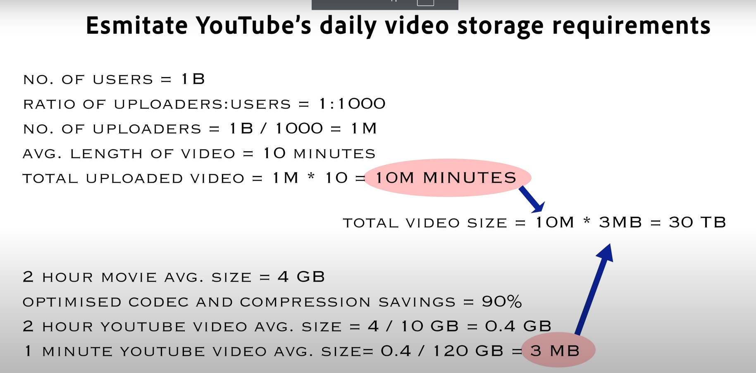

16/11

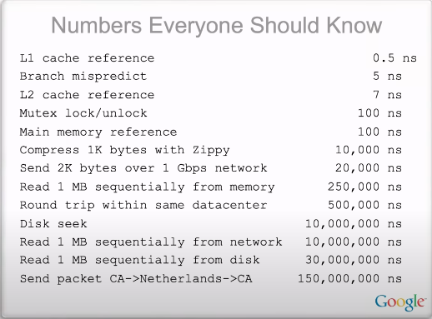

18/11

Consistent Hashing

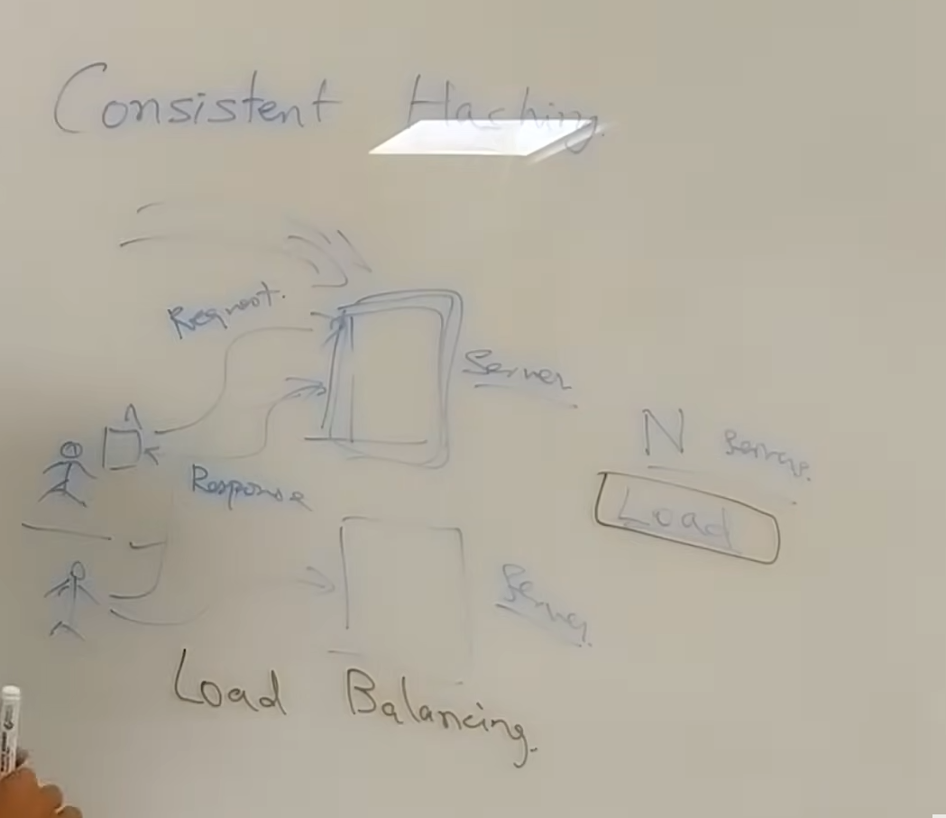





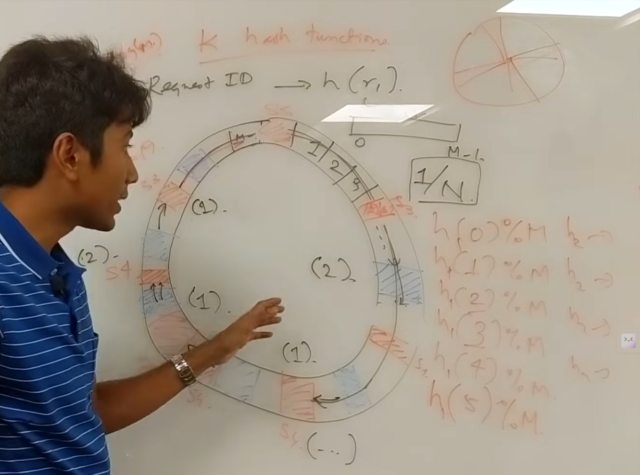

21/11/2024

Sharding

Horizontal partitioning

Database Servers => Consistency, Availability are Important

Data can be sharded in many ways like using userid, but apps like tinder will use location as sharding key such that it effectively shows all the data nearby

Problems :

Joins across the Shard

MEM CACHED

Fixed numbered of shards

* If large shard then further breaks into dynamic number of shards.
* Hierarchical sharding

Best practices

* Creating Indexes

Master Slave Architecture :

1. For Availability.

**Data Stores :**

What are Bloom Filters?











Master Slave Architecture :

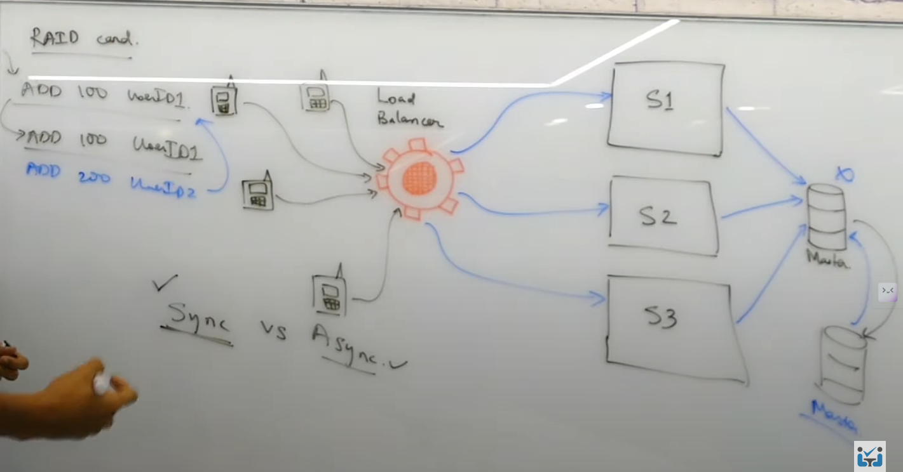

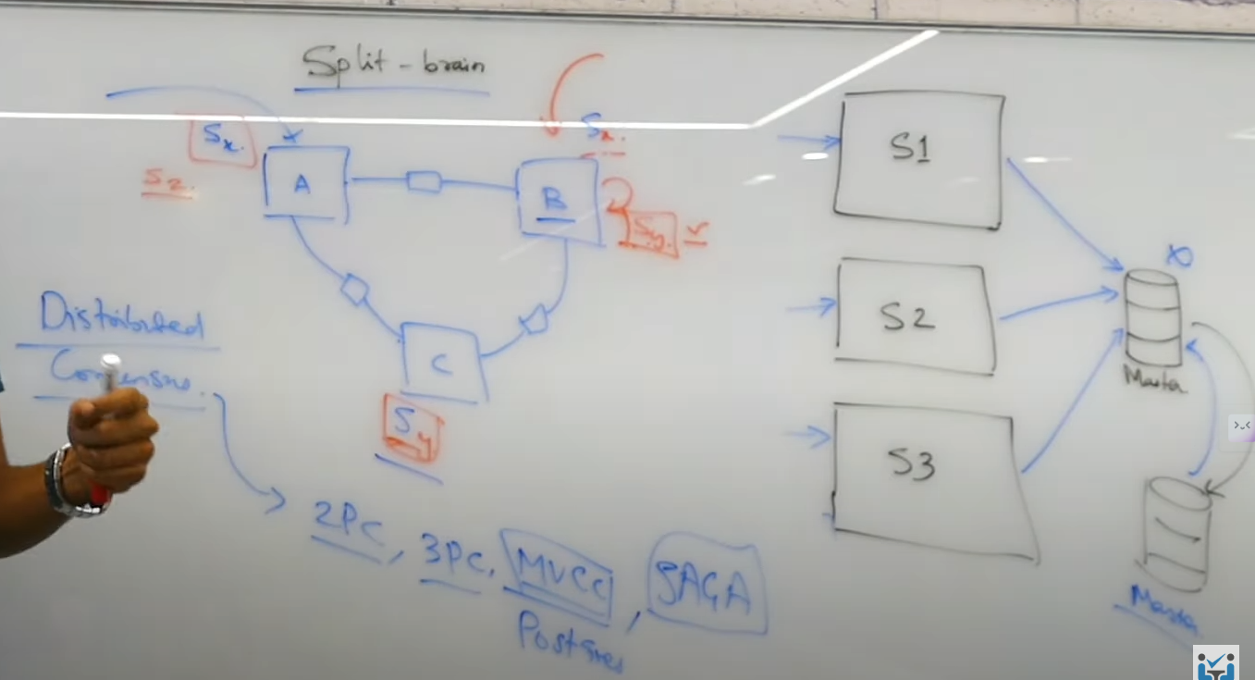

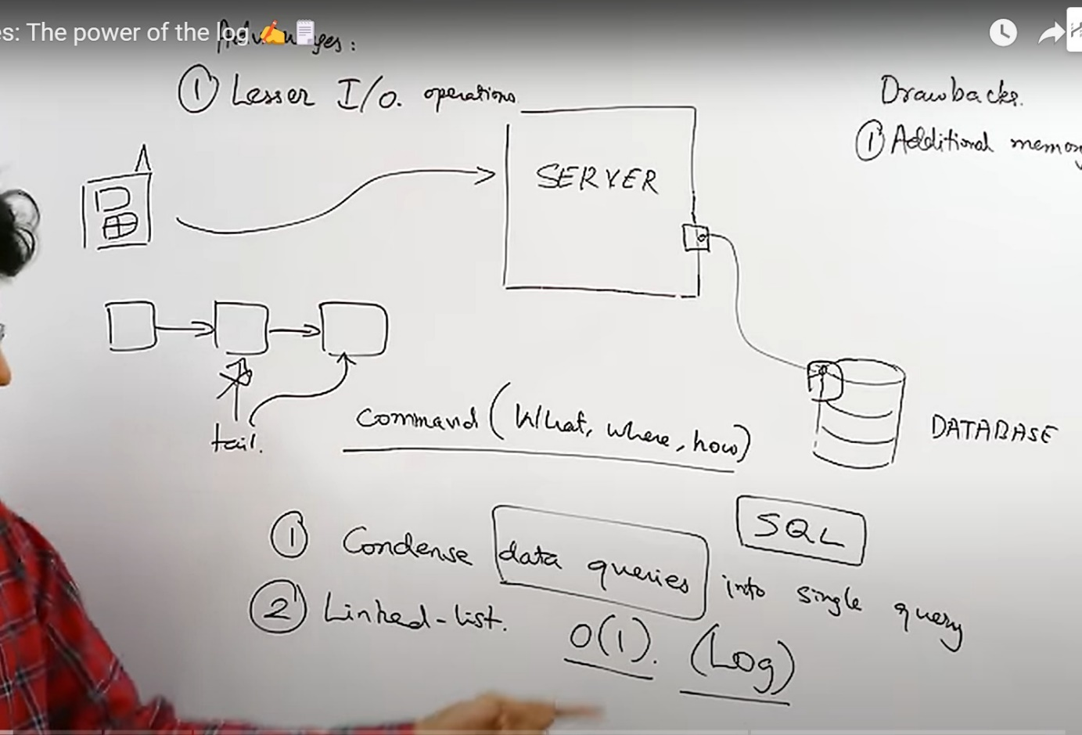

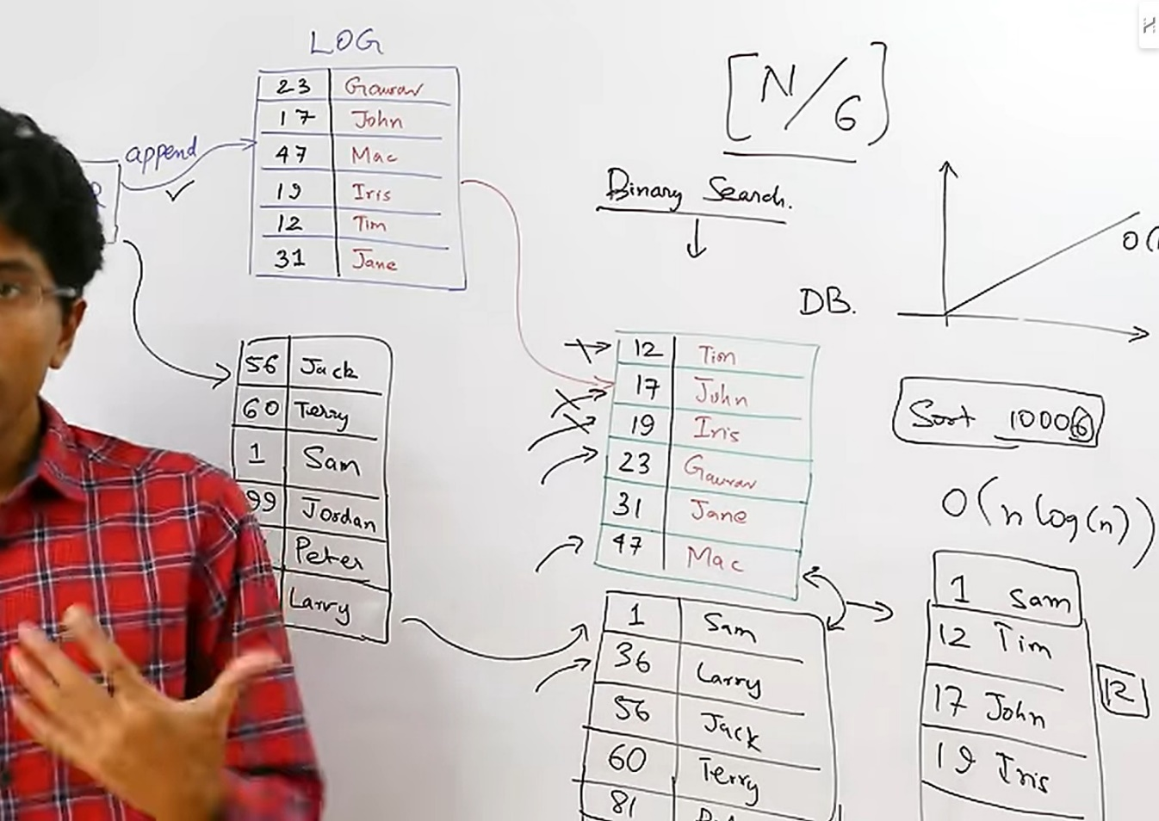



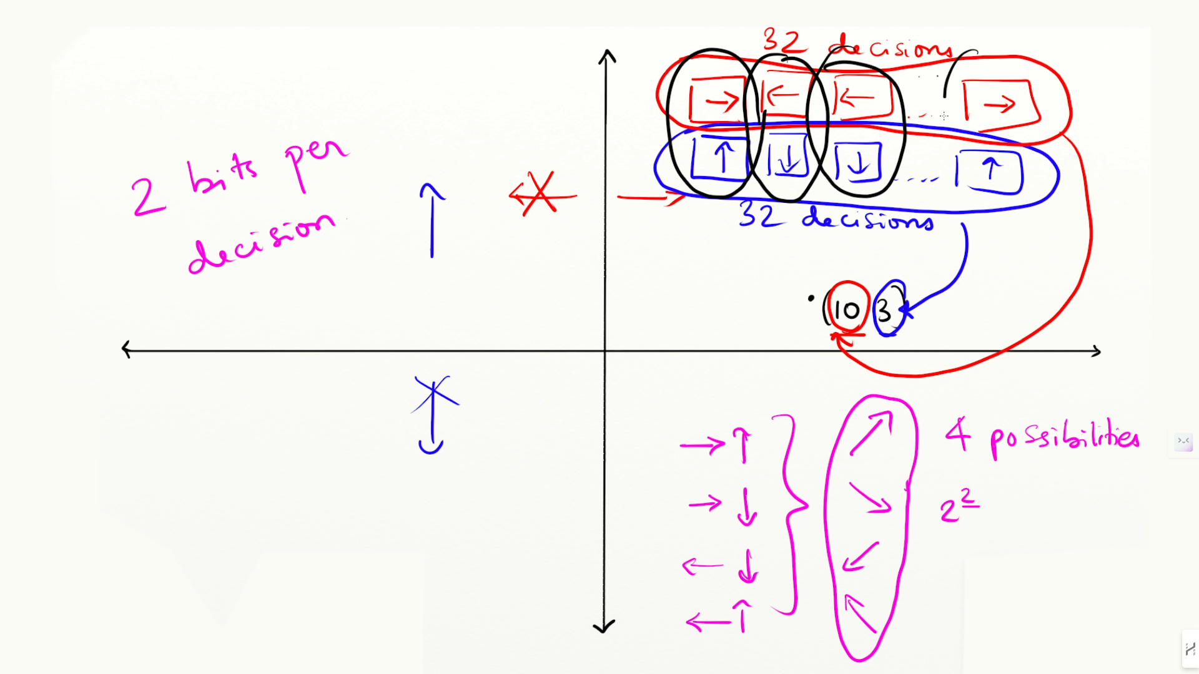

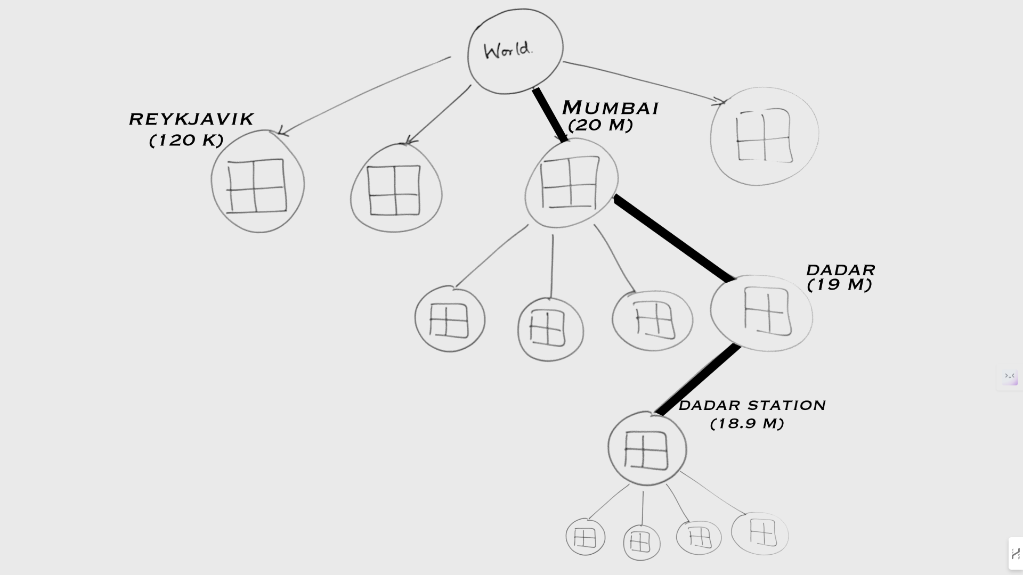

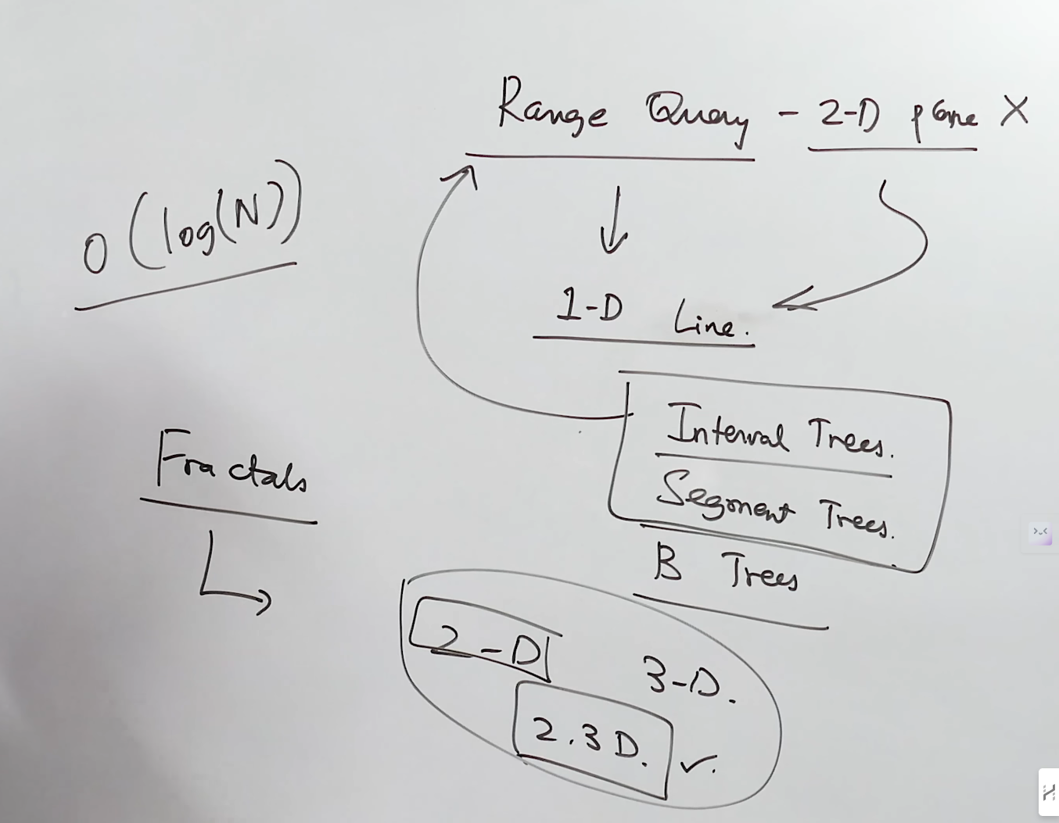

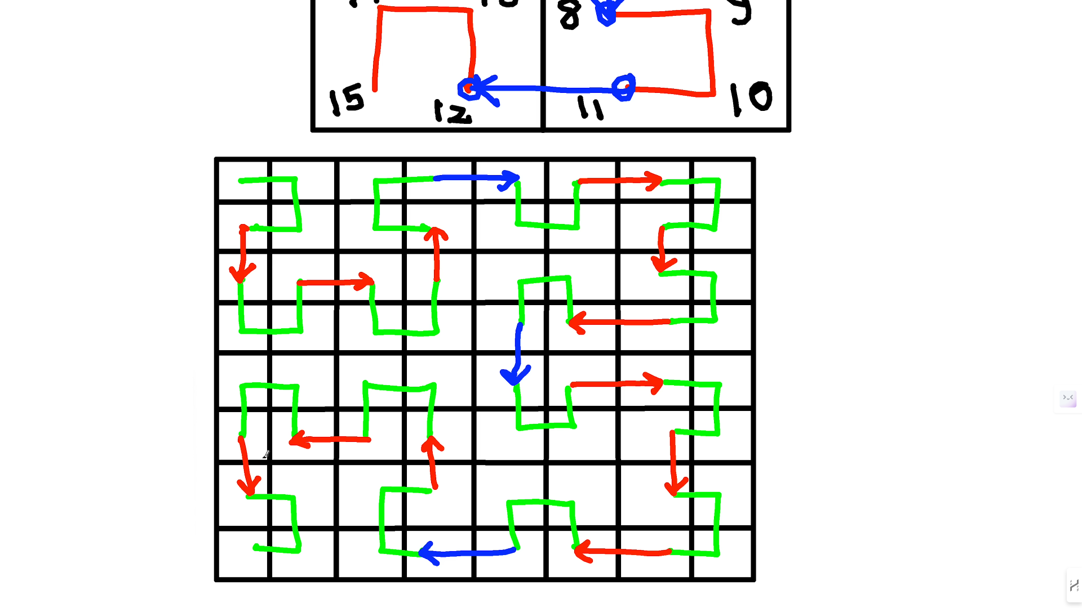

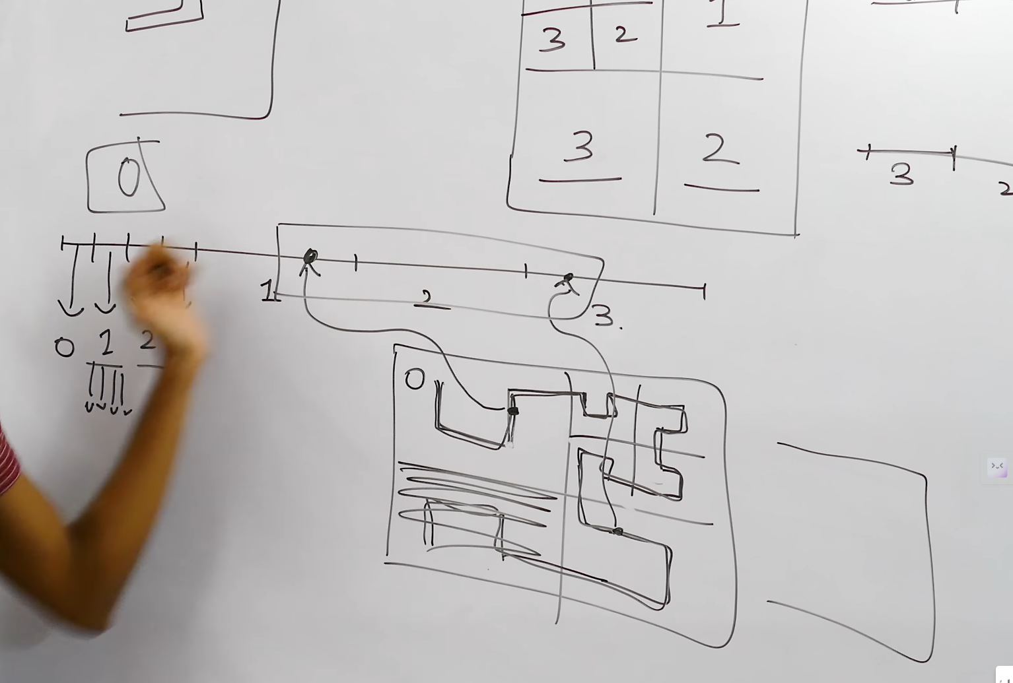

Consistency :

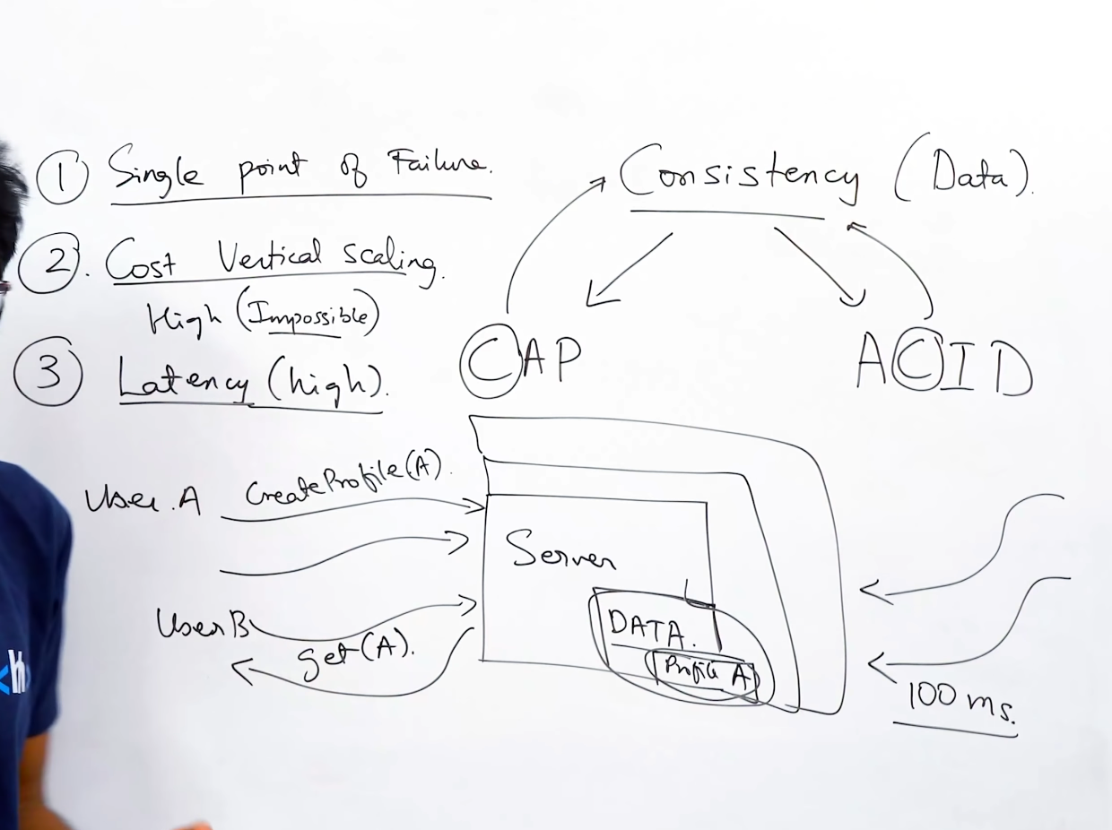

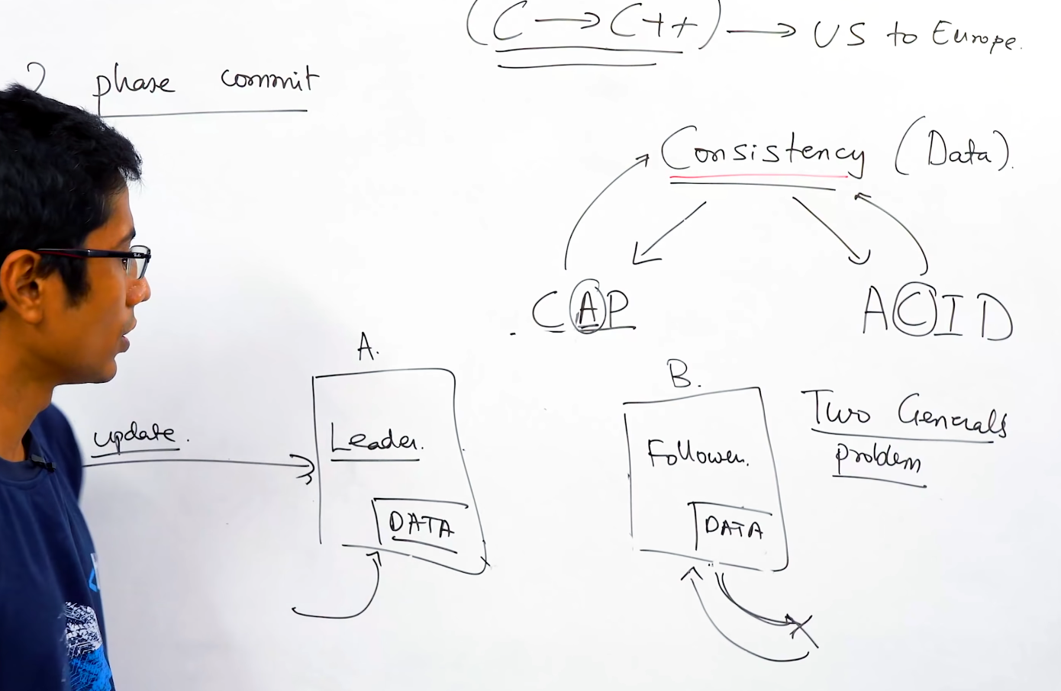

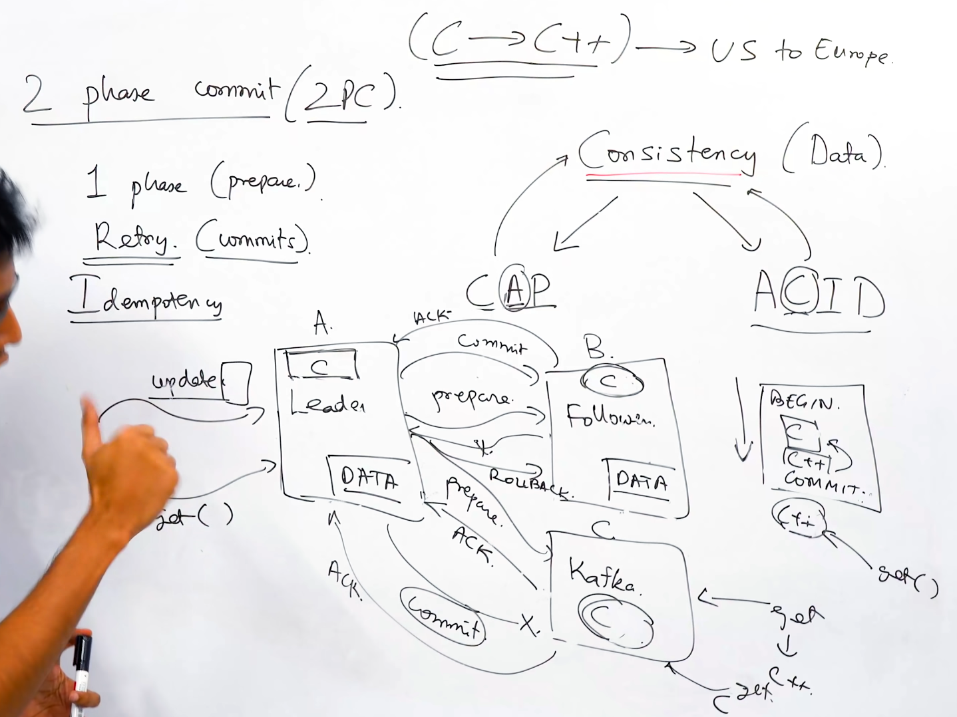

30/11/2024

Message Queuing

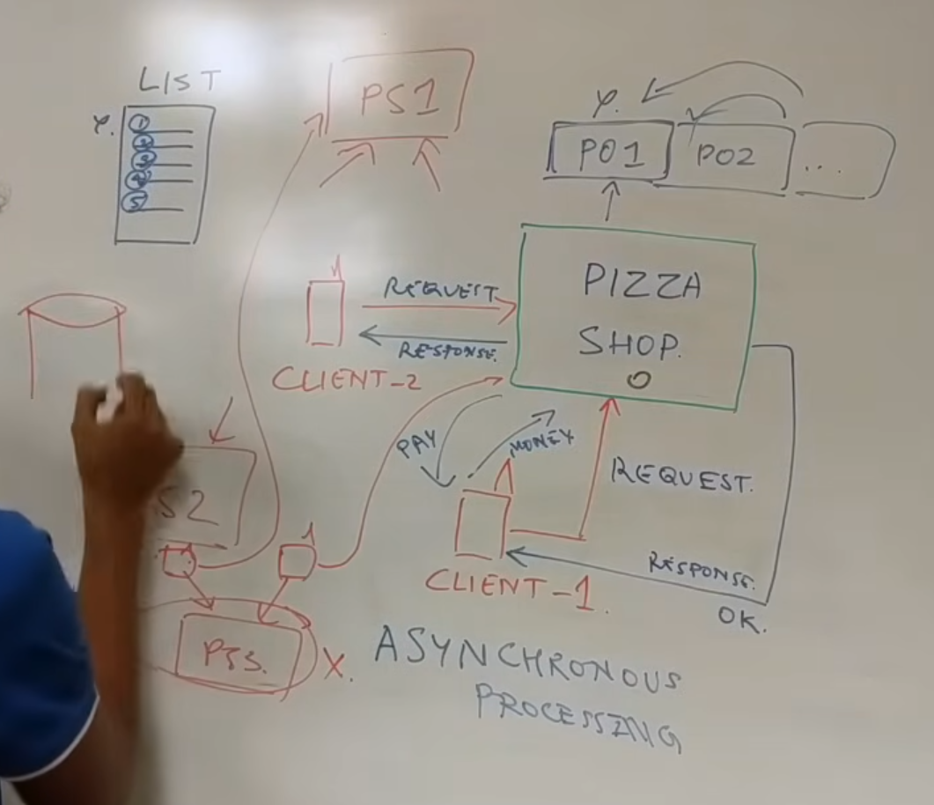

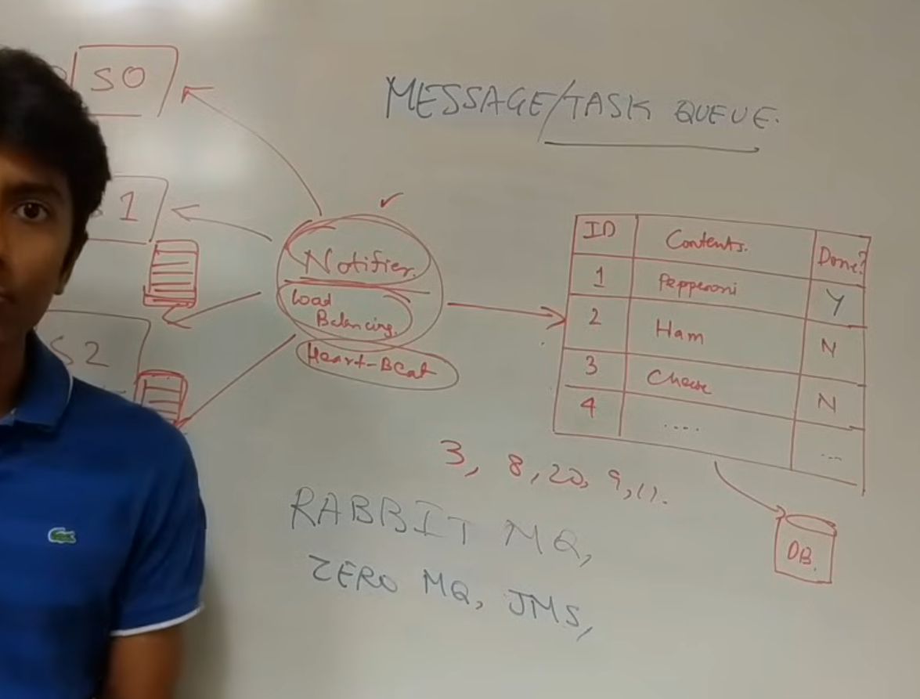

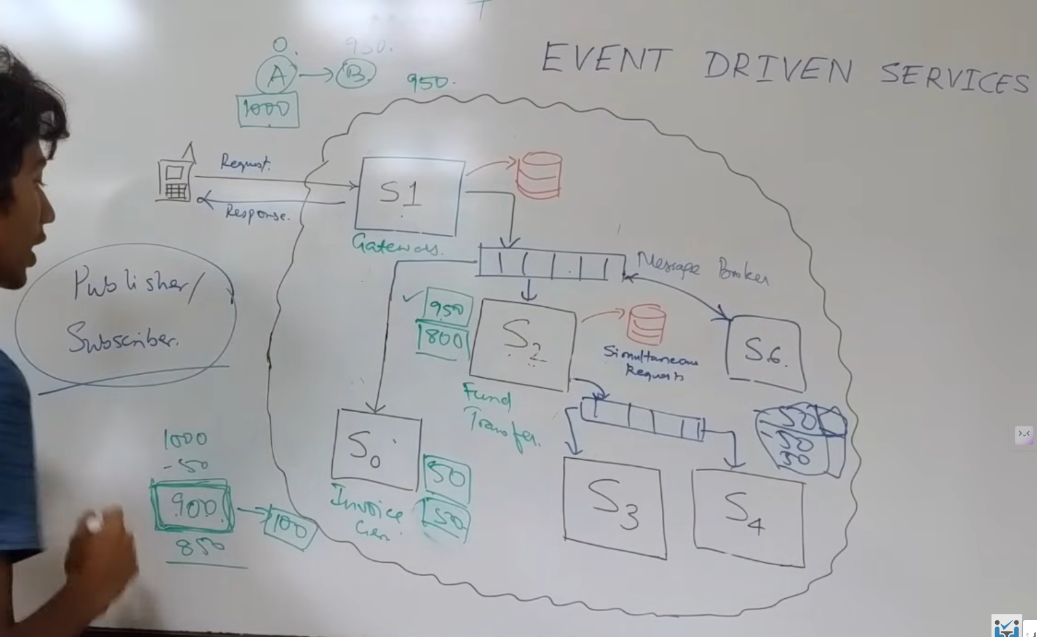

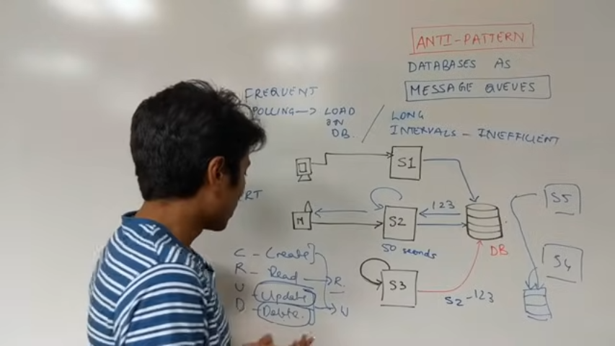

03/12/2024

Devops Concepts

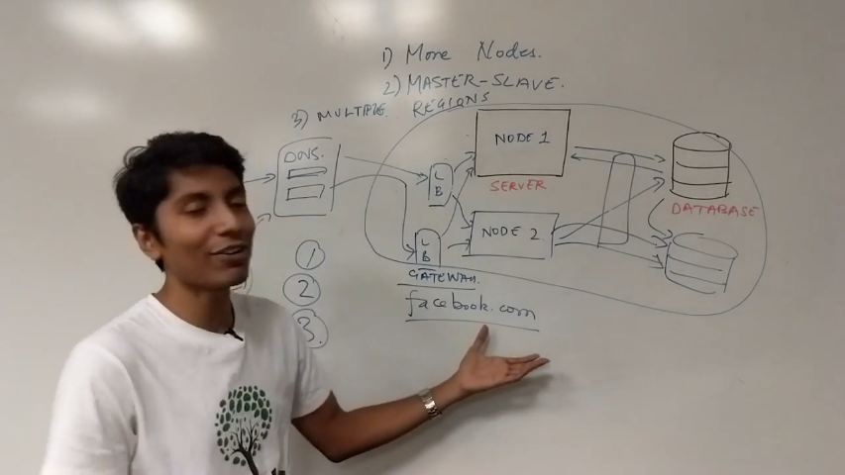

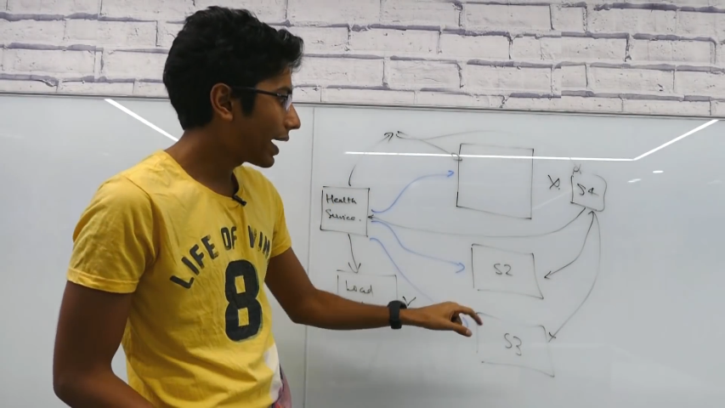



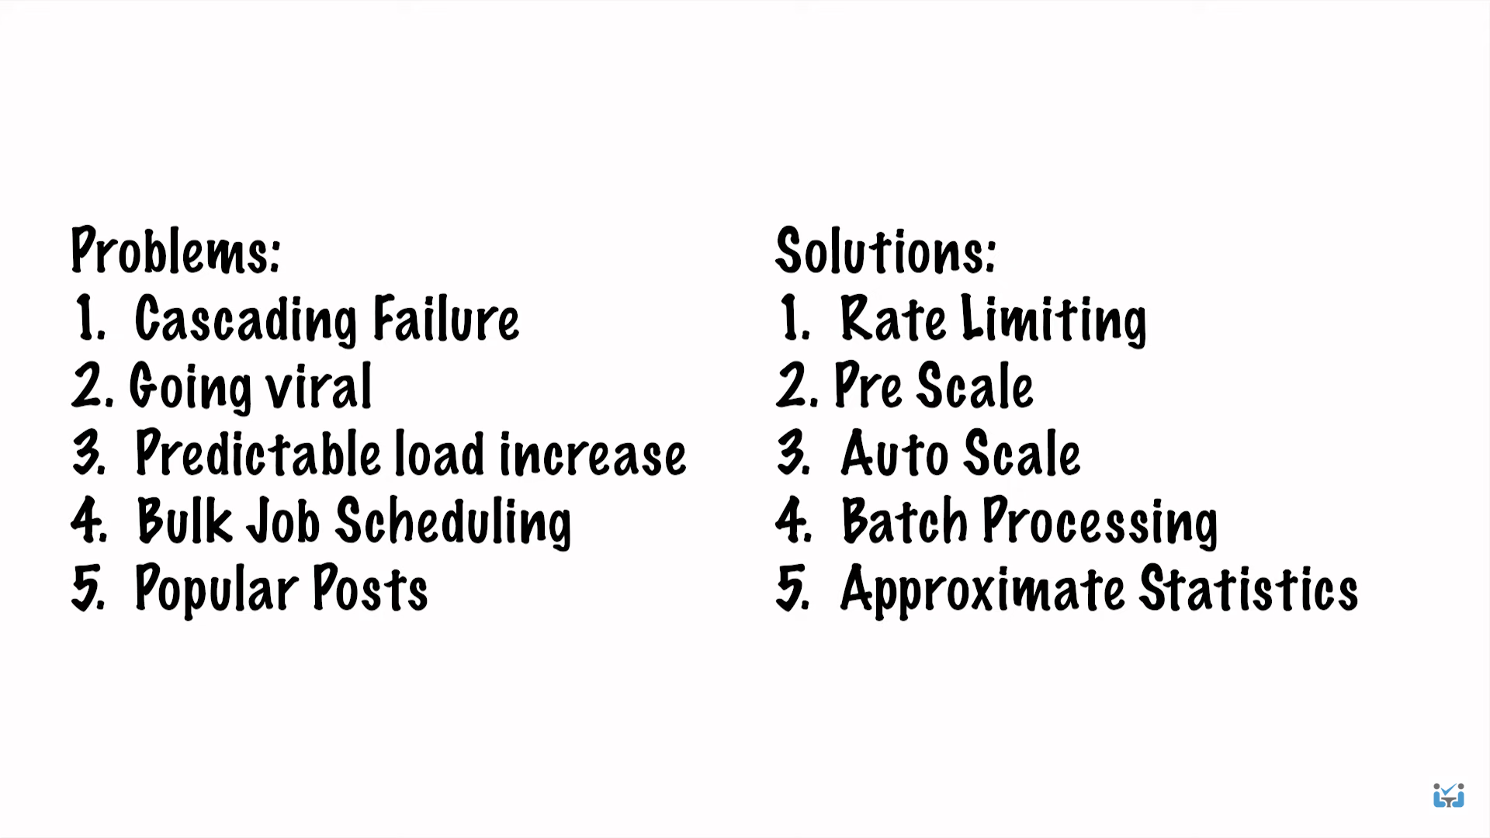

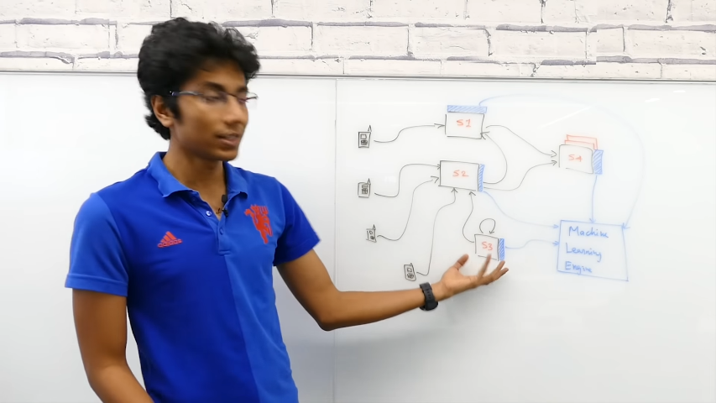

Caching

1. Save network calls
2. Avoid repeated computations.
3. Reduce DB calls

Why not everything in cache?

1. Hardware is expensive for cache
2. If more data in cache also then search time will increase. Counter productive.

Cache Policies.

1. Cache only stores relevant info. (prediction)
2. When do we load data or evict data out of the cache? => policy
3. LRU is mostly used.
4. LFU is not frequently used.
5. Sliding window based.

Poor cache policies.

1. Extra call is useless.
2. Small cache.=> poor cache performance. (Thrashing)

How far the cache should be ?

1. Closer to server/databases.

Use cases of redis DB

Cache :

1. Write Through => change the cache data and then DB
2. Write Back => change in Db and then delete in Cache.

Write-through is not good for multiple caches.

Write-back => performance issue.

Content Delivery Networks:

1. Caching
2. Customized Data(device,location)